Team First

Pet meeting User Manual

1. Basic requirements
   1. Hardware Requirement
      1. Operation System: Windows 10 Pro
      2. Processors: Intel(R) Core(™) i7-7700HQ CPU @ 2.80GHz
      3. Installed Memory(RAM): 8.00 GB
      4. System Type: 64bit operating system, x64 based processors
      5. Network must be supported
   2. Software Requirement
      1. Nodejs: 14.15.0
      2. npm: 6.14.8
      3. docker: 19.03.13, build 4484c46d9d
      4. docker-compose: 1.27.4, build 40524192
2. Npm 설치
   1. Move to Nodejs installation page.
      1. <https://nodejs.org/en/download/>
   2. Click “Windows Installer (.msi) 64 bit” and continue installing

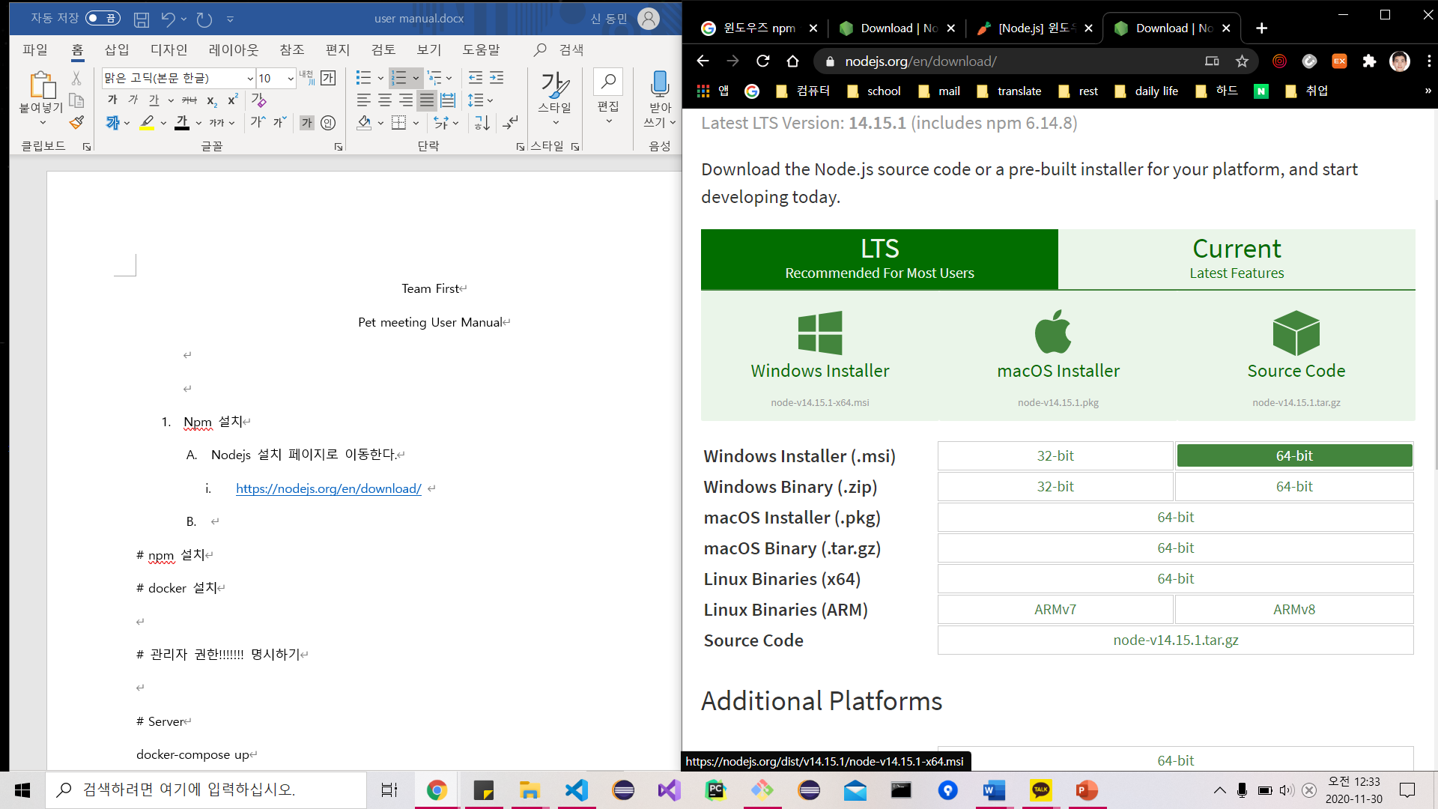

* 1. Click next to continue.

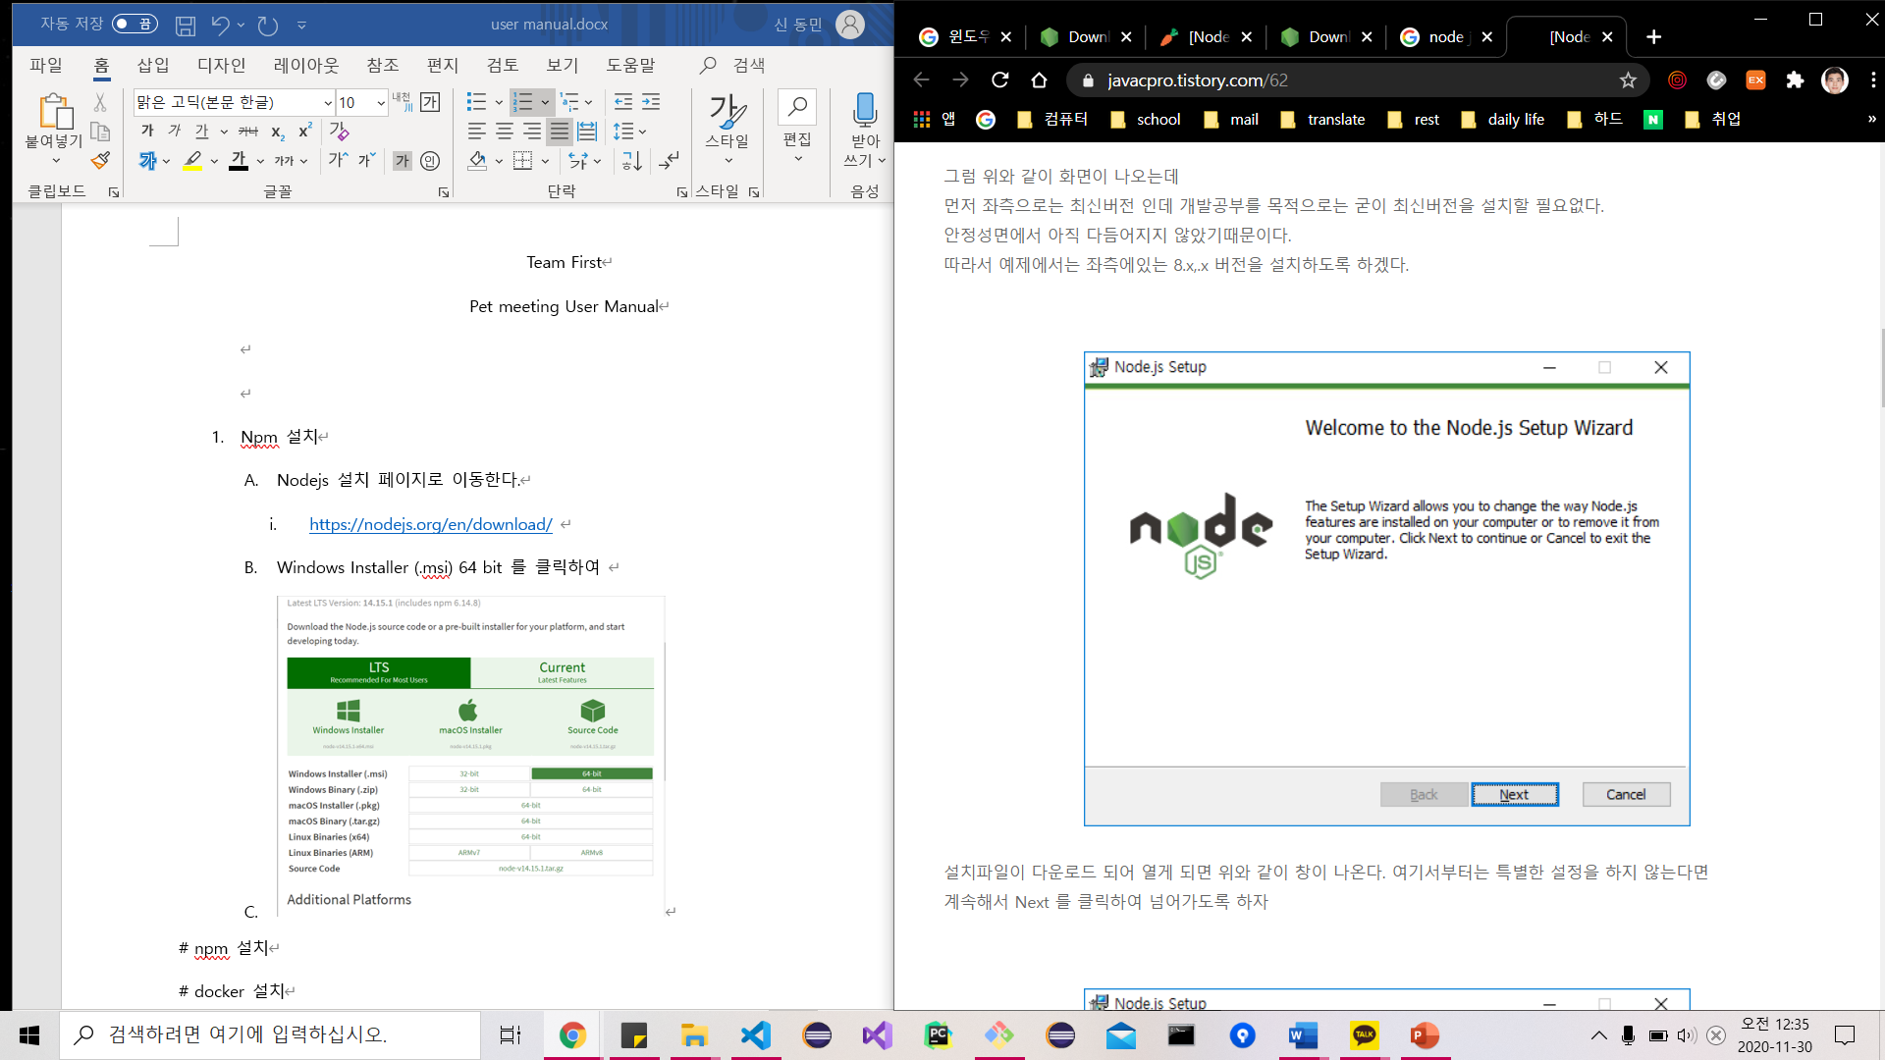

* 1. Click “I accept… “ checkbox to agree the license and progress the installation

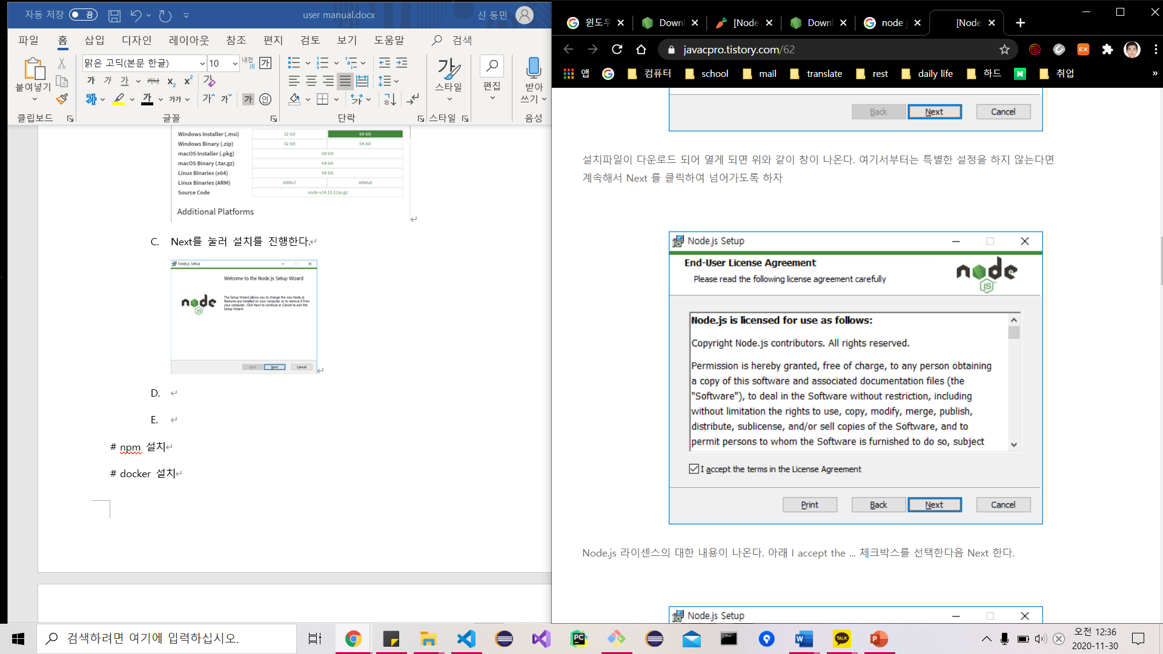

* 1. Click Install button and finish installation

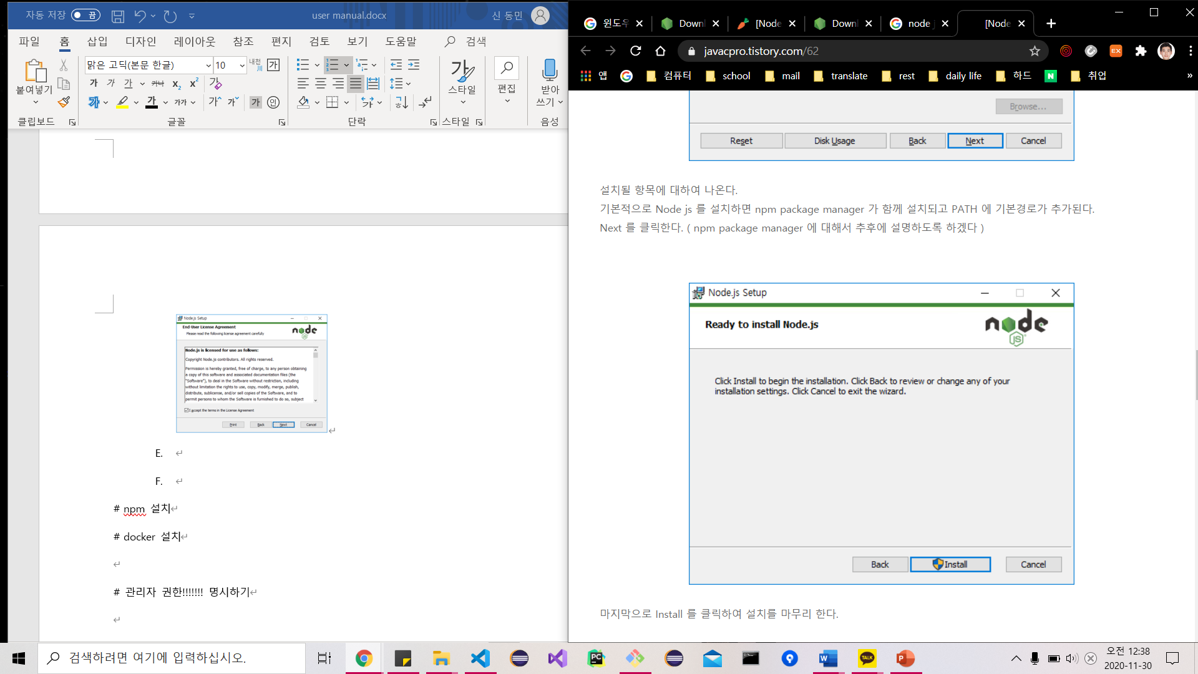

1. installing docker
   1. Activate hyper-v which is virtualization technique
      1. Check whether the virtualization is enabled on task manager (If disabled, set “enable” on BIOS)

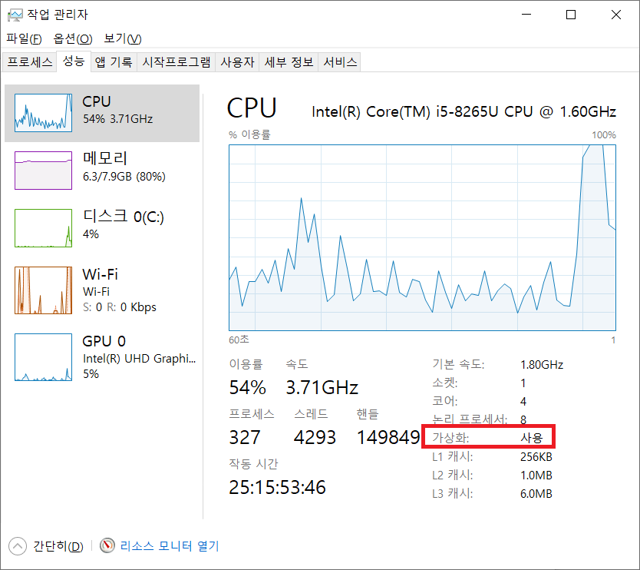

* + 1. - Control panel > Program install and uninstall > Window features > Check Hyper-V > Reboot  
       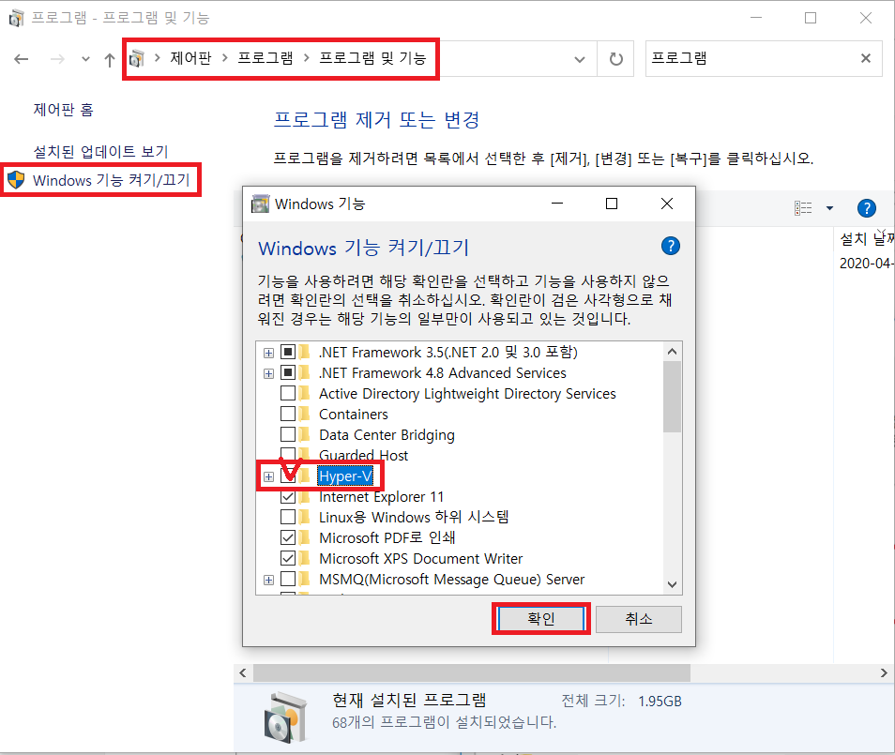
  1. **Download and install Docker installation file**
     1. 다음 사이트 접속 > Get Docker 클릭 하여 다운로드  
        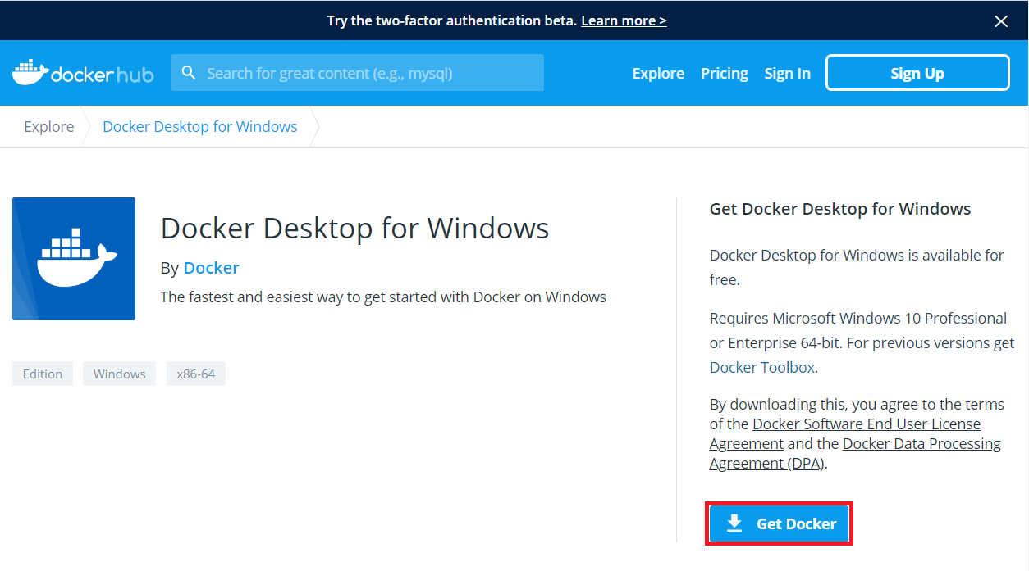
     2. - Execute the downloaded docker file
     3. Configuration

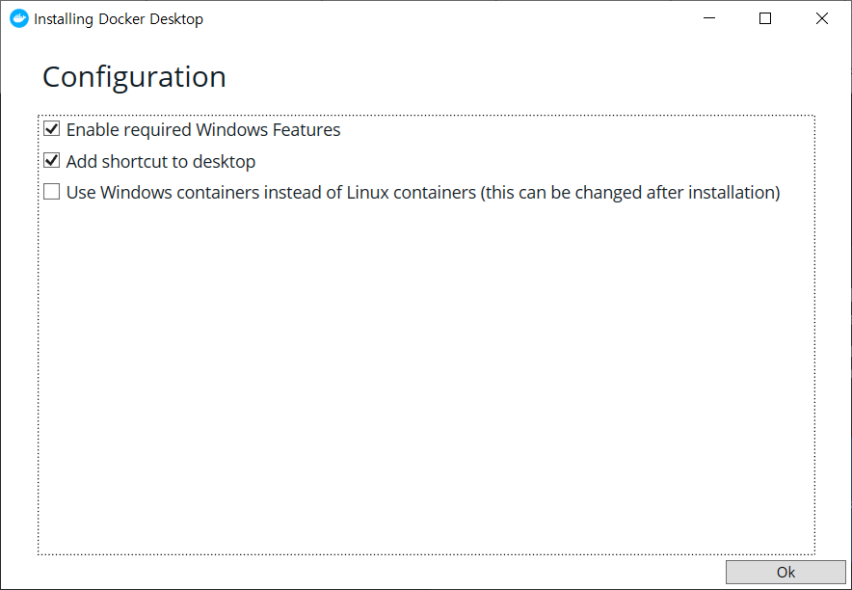

* + 1. If finish, click "Close and restart" to reboot

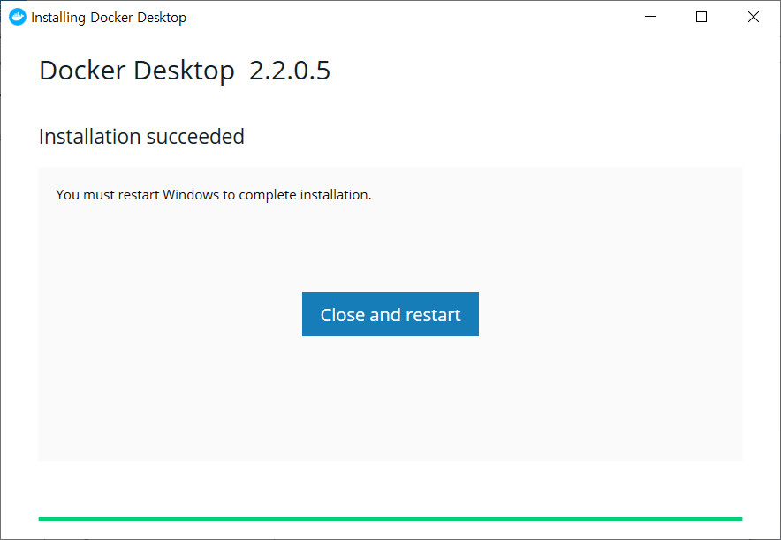

1. Execute source code on Power shell
   1. Execute server using power shell of administrator authentication
      1. Click “Execute on Administrator” and start Windows PowerShell of administrator authentication

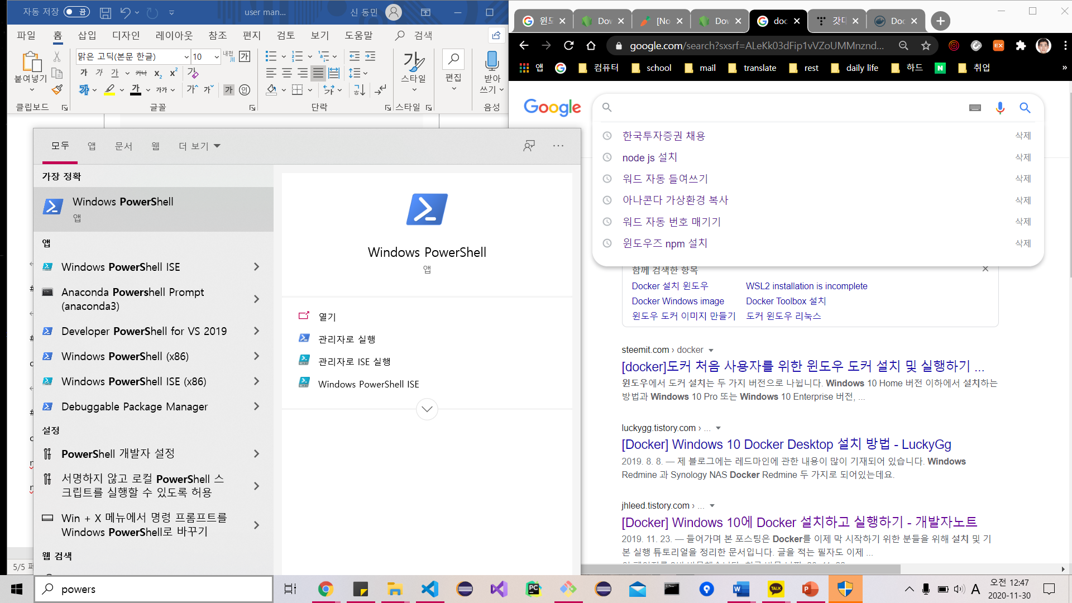

* + 1. Move to ‘Pet-Meeting’ folder in USB
    2. Check if ‘docker-compose.yml’ exists using “dir” command
    3. If there is “docker-compose.yml” file, execute “docker-compose up” command on power shell
  1. Execute client using power shell of administrator authentication
     1. Click “Execute on Administrator” and start Windows PowerShell of administrator authentication



* + 1. Move to ‘Pet-Meeting’ folder in USB
    2. Execute ‘cd Pet-Meeting-Client’ command to move to “Pet-Meeting-Client” folder
    3. Execute ‘npm install’
    4. Execute ‘npm audit fix’
    5. Execute ‘npm start’